Java Map Interface

A map contains values based on the key i.e. key and value pair.Each pair is known as an entry.Map contains only unique elements.

Commonly used methods of Map interface:

1. **public Object put(object key,Object value):** is used to insert an entry in this map.
2. **public void putAll(Map map):**is used to insert the specified map in this map.
3. **public Object remove(object key):**is used to delete an entry for the specified key.
4. **public Object get(Object key):**is used to return the value for the specified key.
5. **public boolean containsKey(Object key):**is used to search the specified key from this map.
6. **public boolean containsValue(Object value):**is used to search the specified value from this map.
7. **public Set keySet():**returns the Set view containing all the keys.
8. **public Set entrySet():**returns the Set view containing all the keys and values.

Entry

Entry is the subinterface of Map.So we will access it by Map.Entry name.It provides methods to get key and value.

Methods of Entry interface:

1. **public Object getKey():** is used to obtain key.
2. **public Object getValue():**is used to obtain value.

# Java HashMap class

* A HashMap contains values based on the key. It implements the Map interface and extends AbstractMap class.
* It contains only unique elements.
* It may have one null key and multiple null values.
* It maintains no order.

## Hierarchy of HashMap class:

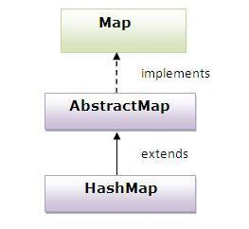

### Example of HashMap class:

1. **import** java.util.*;
2. **class** TestCollection13{
3. **public** **static** **void** main(String args[]){
5. HashMap<Integer,String> hm=**new** HashMap<Integer,String>();
7. hm.put(100,"Amit");
8. hm.put(101,"Vijay");
9. hm.put(102,"Rahul");
11. **for**(Map.Entry m:hm.entrySet()){
12. System.out.println(m.getKey()+" "+m.getValue());
13. }
14. }
15. }

[**Test it Now**](http://www.javatpoint.com/opr/test.jsp?filename=TestCollection13)

Output:102 Rahul

100 Amit

101 Vijay

### What is difference between HashSet and HashMap?

HashSet contains only values whereas HashMap contains entry(key and value).

# Java LinkedHashMap class

* A LinkedHashMap contains values based on the key. It implements the Map interface and extends HashMap class.
* It contains only unique elements.
* It may have one null key and multiple null values.
* It is same as HashMap instead maintains insertion order.

## Hierarchy of LinkedHashMap class:

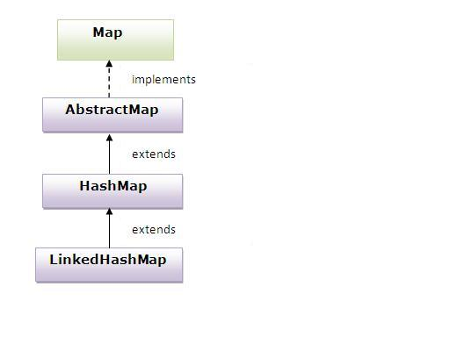

### Example of LinkedHashMap class:

1. **import** java.util.*;
2. **class** TestCollection14{
3. **public** **static** **void** main(String args[]){
5. LinkedHashMap<Integer,String> hm=**new** LinkedHashMap<Integer,String>();
7. hm.put(100,"Amit");
8. hm.put(101,"Vijay");
9. hm.put(102,"Rahul");
11. **for**(Map.Entry m:hm.entrySet()){
12. System.out.println(m.getKey()+" "+m.getValue());
13. }
14. }
15. }

[**Test it Now**](http://www.javatpoint.com/opr/test.jsp?filename=TestCollection14)

Output:100 Amit

101 Vijay

103 Rahul